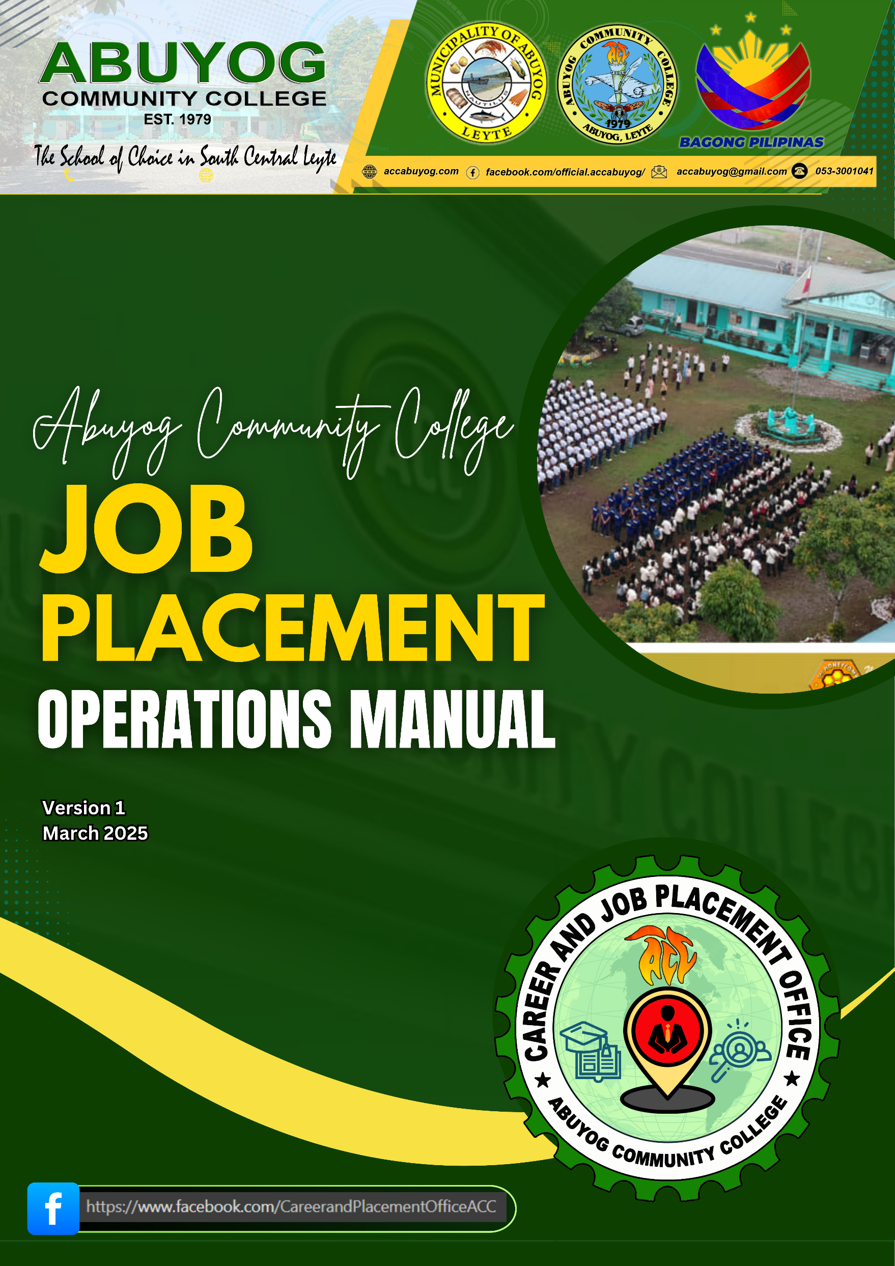

**TABLE OF CONTENTS**

**I. RATIONALE**

**II. OVERVIEW OF ABUYOG COMMUNITY COLLEGE JOB PLACEMENT**

1. VISION, MISSION AND GOALS
2. LOGO

**III. ARTICLES**

1. **Policy Statement**

Section 1

Section 2

Section 3

1. **Scope and Coverage**

Section 1

Section 2

1. **Definition of Terms**

Section 1

1. **Responsibility of Officials /Personnel**

Section 1

Section 2

Section 3

1. **Procedures**

Section 1

Section 2

Section 3

Section 4

Section 5

Section 6

Section 7

1. **Mandatory Evaluation and Review**
2. **Effectivity**



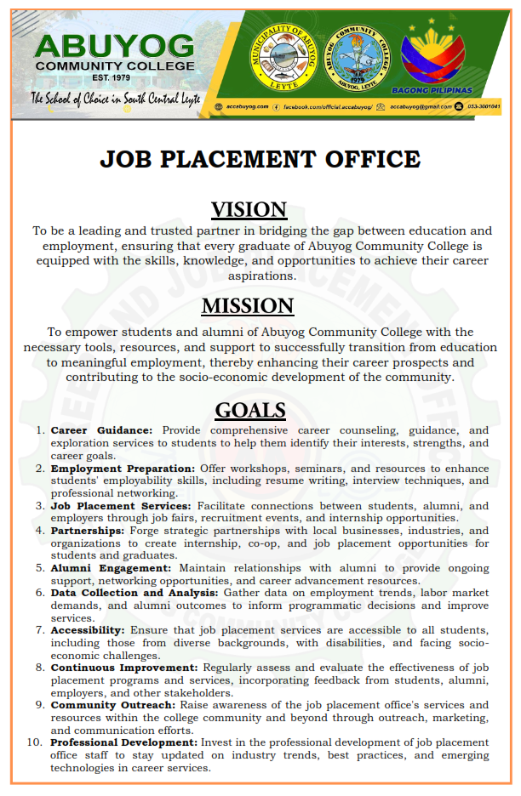

**ACC Job Placement Logo**

The logo for **ACC Job Placement Office**, featuring a Google Map locator symbol serve as body of torch at its center, a alumni at the center of the torch, a searching people symbol, a book with a graduation hat, a world map as background and a gear encircling the logo embodies a profound representation of the Job Placement Office’s mission and values.

1. **Google Map locator as body of the torch:** symbolizes the guiding light that the job placement office provides to individuals seeking employment opportunities. The torch, with its flame represented by the Google Maps locator, represents enlightenment, guidance, and the illumination of pathways towards fulfilling careers.
2. **Alumni at the Center of the Torch:** symbolizing the alumni seeking employment. Placing the alumni at the center of the torch reinforces the organization's commitment to prioritizing the needs and aspirations of job seekers. It signifies that the job placement office is dedicated to empowering individuals in their quest for meaningful employment.
3. **Searching People Symbol:** symbolizes the proactive approach taken by the job placement office in actively seeking out opportunities on behalf of job seekers. It represents the organization's commitment to thorough research and exploration of job markets to ensure the best possible matches for its clients.
4. **Book with a Graduation Hat:** embodies the importance of education and continuous learning in the pursuit of career success. It signifies the knowledge, skills, and qualifications that individuals acquire through education and training, and how these assets contribute to their employability.
5. **World Map:** representing the global scope of the job placement office's services. It symbolizes the organization's commitment to connecting individuals with employment opportunities not only locally but also on a global scale. The world map serves as a reminder of the diverse range of possibilities available to job seekers, reflecting the job placement office's dedication to facilitating access to opportunities worldwide.
6. **Gear Encircling the Logo:** signifies efficiency, productivity, interconnectedness, collaboration, adaptability, innovation, progress, movement, mechanism, and structure. It represents the office's commitment to facilitating successful employment outcomes for individuals and businesses alike, driven by a dynamic and supportive approach to job placement services.
7. **Green Color:** signifies growth, renewal, hope, optimism, balance, harmony, nature, sustainability, freshness, and innovation. It reflects the office's commitment to supporting individuals in their journey towards fulfilling and sustainable employment opportunities, while also embracing innovation and environmental responsibility.
8. **White Color:** signifies purity, clarity, professionalism, sophistication, neutrality, impartiality, space, openness, efficiency, and organization. It reflects the office's commitment to providing transparent, professional, and inclusive job placement services that meet the needs of all stakeholders involved.

Together, these elements embody the office's dedication to guiding, empowering, and connecting individuals with meaningful and sustainable employment opportunities, while embracing innovation and environmental responsibility.

1. **POLICIES AND PROCEDURES OF THE JOB PLACEMENT OFFICE ABUYOG COMMUNITY COLLEGE**

*An SUC–Based Public Employment Service Office (PESO)*

The Public Employment Service Office (PESO) is a non-fee charging multi employment service facility or entity established or accredited pursuant to Republic Act No. 8759 otherwise known as the PESO Act of 1999.

To carry out full employment and equality of employment opportunities for all, and for this purpose, to strengthen and expand the existing employment facilitation service machinery of the government particularly at the local levels there shall be established in all capital towns of provinces, key cities, and other strategic areas a Public Employment Service Office, Hereinafter referred to as PESO, which shall be community-based and maintained largely by local government units (LGUs) and a number of non-governmental organizations (NGOs) or community-based organizations (CBOs) and STATE UNIVERSITIES AND COLLEGES (SUCs).

Abuyog Community College signed a Memorandum of Agreement (MOA) with the Department of Labor and Employment (DOLE) – Regional Office VIII-A last ________. committing its staff and facilities for the establishment, organization and operation of a University-Based Public Employment Service Office. The said MOA remain in full force and effect until revoked or terminated by both parties in writing



1. **ARTICLE I POLICY STATEMENT**

The Job Placement Office ensure the prompt, timely and efficient delivery of employment services and provision of information on other DOLE programs.

**Section 1**. It is the aim of the Job Placement Office to provide useful assistance to both alumni, graduating and undergraduate students of the University in their search for employment related to their field of education, and compatible to their skills and specializations. Furthermore, the office aims to provide clients with adequate information on employment and labor market situation in the area;

**Section 2.** Network with other PESOs within the province/region on employment for job exchange purposes.

**Section 3.** The Job Placement policies and procedures intend to provide career development and job search education to alumni and graduating students, implement pre-employment activities to improve their chances of getting a job and equip them with a network of job openings.

1. **ARTICLE II SCOPE AND COVERAGE**

**Section 1.** The policies and procedures set herein shall be applicable to clients of the Job Placement Office including partner industries/agencies/ companies, alumni, undergraduate and graduating students of the University.

**Section 2.** The policies and procedures cover the steps of the activities of the Job Placement Office which includes: posting and dissemination of job openings, request for the list of graduates, pre-employment activities, job fairs, industry-academe dialogues and recognitions.

1. **ARTICLE III DEFINITION OF TERMS**

**Section 1.** The following terms were defined for better understanding of the policy.

**Clients –** This refers to any company/industry/agency who are availing any of the services provided by the Job Placement Office.

**Company Profile Bank -** This refers to the company profiles of the partner industries of the university for the students and alumni who wish to know the background and nature of business of companies they wish to apply for.

**Employment –** This refers to the relationship between two parties, usually based on a contract, one being the employer and the other being the employee.

**Exclusive Job Fair -** is referred commonly as a career fair or career expo but there is only one employer or recruiter involved in the recruitment of applicants.

**Industry-Academe dialogue/linkage –** This may refer to dialogues between key industry executives and school administrators to provide avenues for important feedback necessary to create and design relevant and updated curricular offerings of the university to the needs of the industry.

**Job exchange –** This refers to the exchange and/or exchange of job vacancies or hiring of different Public Employment Service Office.

**Job Fair -** This refers to the activity of the University in facilitating immediate hiring to cater to the needs of graduating students and alumni and the different industries as well. This is also referred to as career fair or career expo.

**Job openings -** This refers to the information received by the office from the partner industries/agencies/companies, both private and public regarding opportunities/vacancies for posting and dissemination.

**List of graduates –** This refers to the masterlist of students who graduated from the University.

**Memorandum of Agreement (MOA) –** This refers to a document written between the University and another industry/agency/company to cooperate on a project or meet an agreed objective. The purpose of an MOA is to have a written understanding of the agreement between parties.

**Partner industries/agencies/companies –** This refers to any establishment who is in partnership with the University in facilitating employment to alumni, undergraduate and graduating students.

**Pre-employment activities -** This refers to various lecture-seminars and orientation for students which are integral part to prepare them for employment.

**Public Employment Service Office (PESO) –** This refers to a non-fee charging multi-employment service facility or entity established or accredited pursuant to Republic Act No. 8759 otherwise known as the PESO Act of 1999.

**Republic Act No. 8759 –** Also known as the Public Employment Service Office Act of 1999 which an act institutionalizing a national facilitation service network through the establishment of a public employment service office in every province, key city and other strategic areas throughout the country, including SUCs.

**Industry-Academe Linkage Recognition Program–** The Job Placement Office in coordination with the concerned offices and colleges of the University will hold recognition every five years to show gratitude and deep appreciation to the University’s partner industries/agencies/ establishments in their continuous support in providing training and job opportunities to our students and alumni.

1. **ARTICLE IV RESPONSIBILITY OF OFFICIALS/PERSONNEL**

**Section 1. Assistant Director, Job Placement Office.**

Under the supervision of the Director for Office of Student Affairs and Services, the Assistant Director for Job Placement shall be responsible for assisting the Director in directing and coordinating job placements matters in the College:

**1.1.**  Assists the Director in the review and revision of policies and procedures regarding programs and services of the Job Placement Office.

**1.2.**  Assists the Director in the administration and interpretation of laws, regulation, policies and procedures related to job placement.

**1.3.** Acts as a point of reference for all communication concerning job openings. Regularly post on bulletin boards job openings from various establishments and industries.

**1.4.** Assists the Director in endorsing to higher authority transactions regarding Job Placement.

**1.5.** Establishes and maintains harmonious relationship with industry, public and private agencies.

**1.6.** Assists the Director in granting of rewards and recognition to the different cooperating industries/agencies/companies.

**1.7.** Organizes the schedule of all Job Placement activities and orientations for the office.

**1.8.** Assists the Director in requesting to higher authority all documents, supplies and equipment needed in the facilitation of job placement related activities, works or assignment, subject to availability of fund.

**1.9.** Assists the Director in maintaining official master lists of linkages and their profile.

**1.10.** Coordinates and submit reports to the Department of Labor and Employment with regards to programs and accomplishments of the office.

**Section 2. Head, Job Placement Office (Campus/District).**

Under the supervision of the Director of OSAS and Assistant Director of Job Placement Office, the Head shall be responsible for directing and coordinating all job placements matters in their respective campuses:

**2.1.** Assists in the administration and interpretation of laws, regulation, policies and procedures related to job placement.

**2.2.** Evaluates and verifies the qualifications of applicants for placement to schools, hospitals, and companies.

**2.3.**Spearheads the campus orientation, pre-employment seminars/symposium to prepare the students in the network of job market.

**2.4.**  Scouts for possible partnership related to Job Placement both local and international.

**2.5.**  Disseminates and posts the received job vacancies to the bulletin boards in the University and in concerned colleges and departments.

**2.6.**  Entertains/Answers queries regarding job placement concerns.

**2.7.**  Consolidates, prepares, provides concerned offices and keeps master list, resume and other credentials of the campus graduates and graduating students for placement.

**2.8.**  Maintains the data bank of the alumni and graduating students per college for future reference and the manpower needs of the partner establishments.

**2.9.**  Maintains and updates a job placement bulletin board of information.

**2.10** Prepares and submits required reports as scheduled.

**2.11.**  Coordinates with the partner establishment on their request for the list of alumni and graduating students.

**2.12** Assists in the Career Fair of the university and other campus recruitment.

**2.13.**  Consolidates the reports of the job placement coordinators in the campus and submit them to JPO Assistant Director every month.

**2.14.**  Other duties related to job placement as maybe assigned by OSAS Director, JPO Assistant Director.

**Section 3. Coordinator, Job Placement Office (College/Department).**

Under the supervision of the Director of OSAS and Assistant Director of Job Placement Office, the Coordinator/In-Charge shall be responsible for directing and coordinating all job placements matters in their respective departments:

**3.1** Assists in the administration and interpretation of laws, regulation, policies and procedures related to job placement.

**3.2** Evaluates and verifies the qualifications of applicants for placement to schools, hospitals, industries and companies.

**3.3** Spearheads the college orientation/seminars to graduating students regarding labor laws, resume making, handling job interviews and power dressing. Keep master list of graduates for placement and provide those list to requesting agencies/industries.

**3.4** Maintains the data bank of the alumni and graduating students per college for future reference and the manpower needs of partner establishments.

**3.5** Evaluates the credentials and skills of the students for referrals.

**3.6** Accommodates job placement concerns.

**3.7** Assists in the Career Fair of the University and other exclusive campus recruitment.

**3.8** Scouts for possible partnership related to job placement both local and international.

**3.9** Performs other duties as maybe assigned by higher officials.

**5. ARTICLE V PROCEDURES**

**Section 1. Posting and Dissemination of Job Openings.**

The objective of the job posting policies and procedures is to make sure that alumni, graduating and undergraduate students of the University are made aware of and have the opportunity to apply for open positions available in the job market. All job postings will be made available at the Job Placement bulletin board in all campuses and Job Placement social media account.

**1.1** The requesting establishment should accomplish BatStateU-FO-JPO-01 (Request for Job Posting) form to be approved by the Director of Student Affairs and Services upon satisfying documentary requirements: job advertisement, copy of SEC registration certificate or business permit, company background. If the company had previously requested for posting, there will be no need to submit again the documentary requirements. Requirements may be sent to the e-mail address of the office.

**1.2** The received job advertisements/openings shall be double checked before posting and dissemination.

**1.3** The Job Placement Office reserves the right to accept or reject the posting content.

**1.4** The posting and dissemination of the received job advertisement/openings is free of charge.

**1.5** The college heads/coordinators/in-charge is expected to post the job advertisement immediately to the designated bulletin of information for each college/departments.

**1.6** Resume and other credentials of interested applicants maybe submitted to the official e-mail account for referral to the requesting company.

**1.7** The partner establishment and other requesting party shall provide the Job Placement Office the layout of the advertisement for job posting which shall include the following details:

a. Job title

b. No. of vacant positions

c. Minimum requirements for the job

c.1 Educational Qualification

c.2 Experience

c.3 Skills & other requirements

d. Job Description

d.1 Job summary

d.2 Duties and responsibilities

d.3 Other/location of the job

**1.8** Posted/job advertisement/openings shall be filed and consolidated by the office for future reference.

**1.9** Job postings shall be discarded from bulletin boards 1 month after their stamped date of posting and shall be filed and consolidated for future reference.

**Section 2. Request for list of graduates/alumni.**

The Job Placement Office shall be responsible for processing all requests of partner industries/companies/agencies for the list of graduating students and alumni for immediate job placement.

**2.1** The requesting establishment should accomplish BatStateU-FO-JPO-02 form to be approved by the Director of Student Affairs and Services upon satisfying documentary requirements: copy of SEC registration certificate or business permit, company background. If the company had previously requested alumni list, there will be no need to submit again the documentary requirements. Requirements may be sent to the e-mail address of the office.

**2.2** Upon approval, the list and complete details of the graduates/alumni will be forwarded to the requesting industries/agencies/establishments for free via email or fax by the Job Placement Office.

**2.3** After 30 days of receipt of the requested documents, the Job Placement office will conduct a follow up to the industries/agencies/establishments on the status of their hiring activity through BatStateU-FO-JPO-06 form (Employment Follow-up Form) which shall be sent and retrieved via email.

**2.4** Prepare a list of hired graduates from the retrieved survey form from the partner companies who requested for the alumni list.

**2.5** Should any company request for the top performing students of the University who could fill in their vacant positions, the Job Placement Office will coordinate the matter to the Deans of the concerned colleges/departments before referring them to the requesting industries/agencies/establishments.

**Section 3. Pre-employment Activities.**

The Job Placement Office sponsors various lecture-seminars, orientation and symposia which can contribute to their employability. Topic includes resume making, power dressing, handling job interviews, basic rights and privileges of an employee, career development and education, personal and professional adaptability.

**3.1** The Job Placement Office must accomplish BatStateU-FO-REQ-05 form (Request for Meeting) for the conduct of such activity one (1) month ahead of the target schedule. Estimated budget for expenses should also be attached for reference

**3.2** Once approved, proper communication shall be done to the concerned offices/departments of the University for the use of venue and for the dissemination of information to concerned students.

**3.3** Students from third year and fourth year college of the University are qualified to attend the training and seminar.

**3.4** The campus head/coordinator will determine the number and eligibility of the participants.

**3.5** Registration for trainings and lecture-seminars are free. Pre-registration for the participant from the satellite campuses should be facilitated by the placement heads/coordinators/in-charge to ensure maximum or full participation the number of participants.

**3.6** A narrative report and evaluation report should be prepared by the office for the improvement of the future conduct of the same activity. Liquidation of expenses should also be prepared and submitted to the accounting office during the reglementary period subject to usual accounting and auditing rules and regulations.

**Section 4. Career Fairs.**

The career fair and campus recruitment is conducted to facilitate immediate hiring for both employers and job seekers. Before the Career Fair

**4.1** The Job Placement Office must prepare in the conduct of the career fair (1) month ahead of the target schedule. Estimated budget, venue, budget allocation, participants, committees, tokens, certificates, food and invitations should also be attached for reference.

**4.2** Once approved by the University President, the Job Placement Office should also submit documentary requirements to the Department of Labor and Employment – Province of Batangas to be able to secure a clearance.

**4.3** Advertise the conduct of the career fair to different partner industries/ companies/agencies and alumni.

**4.4** Coordinate with the Alumni Affairs Office and seek assistance for dissemination of information of the career fair and recruitment activity to the alumni of the university who are still seeking for a job.

**4.5** Prepare the invitation letter to be given to the partner companies, schools, and hospitals, private and public agencies which will be signed by the University President. The invitation letter should include the details of the activity and the requirements to be submitted by the invited companies.

**4.6** Conduct follow up to the partner establishment through phone calls and email, accept confirmations and entertain queries from the company and students on the conduct of the event.

**4.7** Meet the key players before the event and conduct a pre-evaluation of their assigned tasks.

**4.8** Inform all the satellite campuses through its respective Executive Director on the details of the event.

**4.9** Conduct a pre-registration to all the undergraduate, graduating and alumni of the university through its respective heads, coordinators or in-charge per college/ campus.

**4.10** Prepare the program and disseminate them to the concerned key players of the event.

**4.11** Prepare name tags, certificates of recognition, program and CD containing the list of graduates to be given to the participating company.

**4.12** Prepare the examination and interview rooms, computer laboratory if the company request for the use of such facilities a day before the event. The requesting party should be informed about the payment and the terms and conditions for the use of such University facilities.

**4.13** Participating companies shall not be charged of any fee in the career fair organized by the University. However, if the company is the one who requested for an exclusive career fair, they must accomplish BatStateU-FO-JPO-04 form and upon approval by the University president, the requesting company must pay three thousand pesos (P 3,000.00) to defray expenses for the venue and electricity consumption. They will also be charged with an additional amount in case of special needs/additional facilities such as use of computers for simulation examinations. The amount for the use of additional facilities will be determined in coordination with concerned offices (e.g. Information and Communication Technology Office and Resource Generation Office). The payment will be made directly to the Cashier’s Office of the University. During the Career Fair:

**4.14** Supervise the conduct of the Career Fair and provide assistance to the needs of those who are seeking for a job and the participating companies.

**4.15** Provide enough utility personnel who will supervise for the overall maintenance of electrical connections, cleanliness and orderliness of the venue and perform errand task during the entire event.

**4.16** Distribute and retrieve the evaluation instrument from the participants both participating companies and applicants. After the event:

**4.17** Conduct a post evaluation of the Career Fair. Gather the key players and get their comments and suggestions for the betterment of the future conduct of the same event.

**4.18** Summarize and evaluate the comments and suggestions of the students, companies, and university officials for improvement of the next Career Fair.

**4.19** Prepare and submit accomplishment report and liquidate the expenses incurred on the conduct of the Career Fair. 4.20 Evaluate the status of application of qualified students after thirty (30) days.

**Section 5. Industry-Academe dialogue/linkage.**

The Job Placement Office may assist in the schedules of dialogues between key industry executives and school administrators to provide avenues for important feedback necessary to create and design relevant and updated curricular offerings of the university to the needs of the industry.

**5.1** Establish and maintain harmonious relationship with industry, private and public agencies for mutual benefits in the CALABARZON area, Metro Manila and nearby provinces.

**5.2** Assist the university and the industry in the signing of Memorandum of Agreement to strengthen university linkages.

**5.3** Scout for other prospective establishments for future partnership by visiting new industries where students are having their OJTs.

**Section 6. Company Profile Bank.**

The office shall maintain data bank of company profiles for students and alumni who wish to know the background and nature of business of companies they wish to apply.

**6.1** Prepare and maintain the list and contact details of the University’s partner industry, private and public agencies for future placement of students and alumni.

**6.2** Make this company profile available to students and alumni for reference for job placement.

**Section 7. Industry-Academe Linkage Recognition Program**

The Job Placement Office in coordination with the concerned offices and colleges of the University shall hold recognition every five continuous years to show gratitude and deep appreciation to the university’s partner industries/ companies/agencies in their continued support in providing training and job opportunities to students and alumni.

1. **ARTICLE VI MANDATORY EVALUATION AND REVIEW**

By the end of each academic year, the University shall conduct a mandatory review of the policy as to the status of its implementation and compliance to existing rules and regulations for possible revisions or amendments.

1. **ARTICLE VII EFFECTIVITY**

These procedures/guidelines shall take effect immediately upon the approval of the University Board of Regents and shall be effective unless otherwise repealed or amended.